Security Evaluation and Risk Analysis Report

Author: Mohammed Hasan Shaikh, Report Updated On: 25/02/2026

Contents
Security Evaluation and Risk Analysis Report 1
1. Introduction 3
2. Vulnerability Scan Using OpenVAS Tool 3
3. Metasploitable3 Machine Attack Simulation 13
4. OWASP Juice Shop Attack Simulation 18
5. OWASP Top 10 Vulnerabilities 20
6. Lessons Learnt & Conclusion 21
7. References 21

Introduction
In this report, I will discuss the fundamental theoretical knowledge and practical skills required to perform a comprehensive security assessment using open-source tools and structured methodologies. The report will begin by explaining how I conducted vulnerability scan with OpenVAS tool, document findings systematically, and apply structured risk assessment techniques to prioritize identified vulnerabilities effectively by creating suitable risk rating, risk matrix and other required risk analysis related tables. I will then discuss about how I simulated attack on Metasploitable3 machine using the Kali Linux tools (Metasploit Framework and Nmap). Finally, I will discuss how I simulated an attack on the practical leading platform OWASP Juice Shop to emphasize its vulnerabilities. Additionally, I will take suitable screenshots throughout the report to show clear evidence of the attacks and scans performed.

Vulnerability Scan Using OpenVAS Tool
In this segment of the report, I will discuss on how I performed vulnerability scan on the target Metaploitable3 machine (Target IP Address: 192.168.1.38) using OpenVAS tool effectively. I will use screenshots and tables as evidence.

I performed OpenVAS scanning on the target Metasploitable3 machine. This is shown through screenshots below.
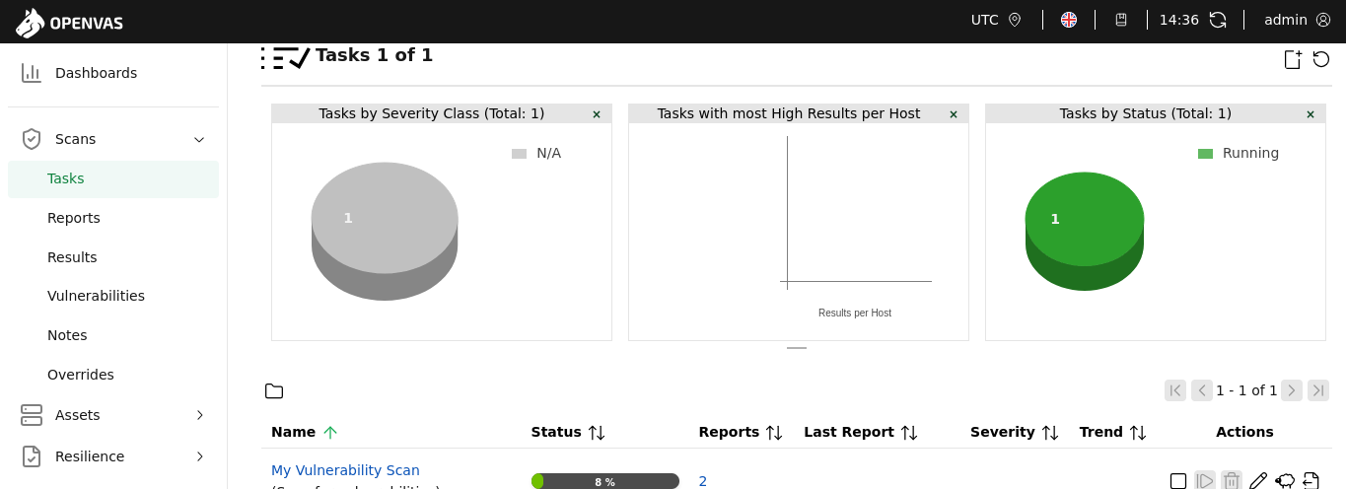

Figure 1: Metasploitable3 Vulnerability Scan – Tasks

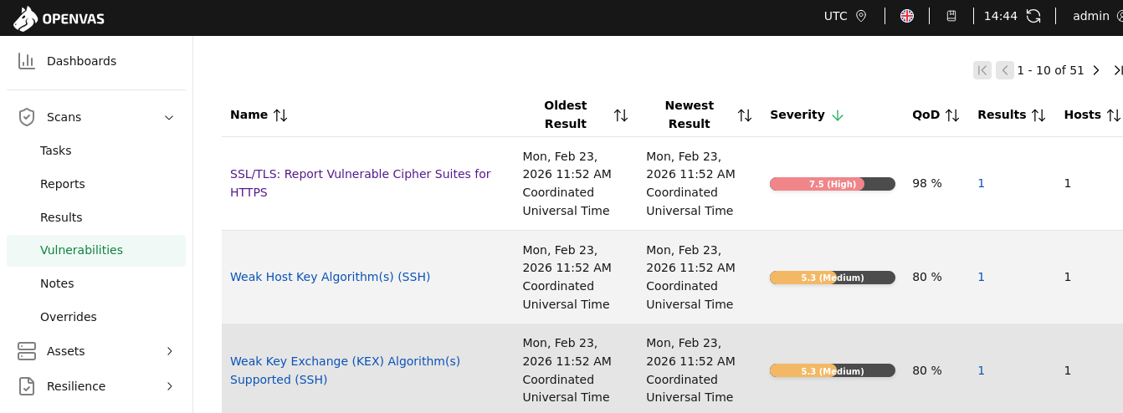

Figure 2: Metasploitable3 Vulnerability Scan – Vulnerabilities Found

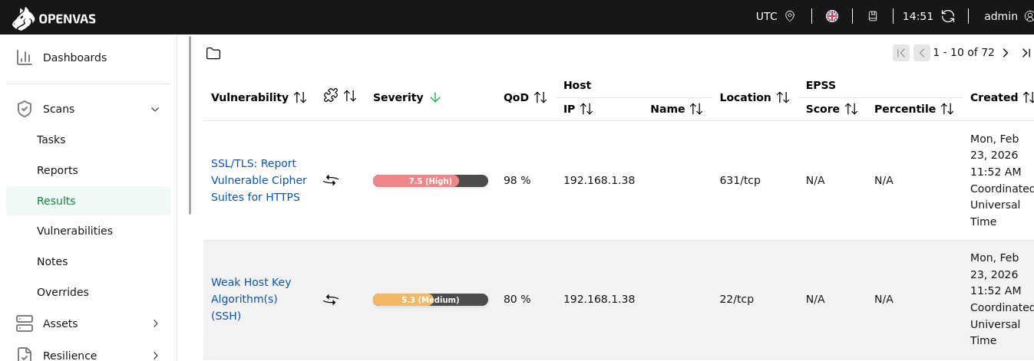

Figure 3: Metasploitable3 Vulnerability Scan – Results Found

The below are the important Risk Analysis Tables I have created to better understand the vulnerabilities, risks and its scores.

Score | Likelihood | Description
3 | High | Easily exploitable remotely, no special conditions required
2 | Medium | Exploitable under certain conditions
1 | Low | Requires unlikely or complex attack scenario

Table 1: Likelihood Scale

Score | Impact | Description
3 | High | Confidentiality, Integrity, or Authentication compromise possible
2 | Medium | Security weakening, enables further attack
1 | Low | Information disclosure or minor hardening issue

Table 2: Impact Scale

Risk Score | Risk Level | Action Required
7-9 | High | Immediate remediation
4-6 | Medium | Planned remediation
1-3 | Low | Acceptable / Hardening

Table 3: Risk Score/Level with my risk prioritization and remediation plan

Risk Score = Likelihood Score X Impact Score

Now, below is the table showing the vulnerabilities found through OpenVAS Scan with its risk score, risk level and a short justification as to why these scores were assigned to the vulnerabilities.

# | Vulnerability | Likelihood (1-3) | Impact (1-3) | Risk Score (LXI) | Risk Level | Justification
1 | SSL/TLS Weak Cipher Suites (3DES – SWEET32) – CVE-2016-2183 | 3 | 3 | 9 | High | Remotely exploitable cryptographic weakness affecting confidentiality
2 | Weak SSH Key Exchange (1024-bit DH / SHA1) | 2 | 3 | 6 | Medium | Requires targeted attack but impacts secure session confidentiality
3 | Weak SSH Host Key (DSA – ssh-dss) | 2 | 2 | 4 | Medium | Deprecated algorithm reduces authentication strength
4 | Weak SSH Encryption Algorithms (CBC / RC4) | 2 | 2 | 4 | Medium | Weak ciphers may allow ciphertext recovery attacks
5 | Weak SSH MAC Algorithms (MD5 / SHA1-96) | 2 | 2 | 4 | Medium | Message integrity algorithms are outdated
6 | Deprecated TLS 1.0 / 1.1 – CVE-2011-3389 | 1 | 2 | 2 | Low | Known weaknesses but less commonly exploited today
7 | FTP Unencrypted Cleartext Login | 3 | 2 | 6 | Medium | Credentials can be easily sniffed on network
8 | TCP Timestamps Information Disclosure | 2 | 1 | 2 | Low | Minor uptime information leakage
9 | ICMP Timestamp Reply Disclosure | 3 | 1 | 3 | Low | Easily triggered but minimal security impact

Table 4: Complete Detailed Vulnerability Risk Scoring Table

Now, below are the two risk matrix tables I have created to evaluate, prioritize, and manage risks in a structured and visual way. One is a normal standard risk matrix table created in excel sheet and the second one includes the vulnerabilities.
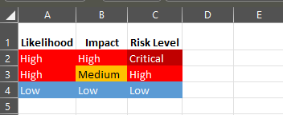

Figure 4: Standard Risk Matrix Table – Excel Sheet

Likelihood \ Impact | Low Impact | Medium Impact | High Impact
High Likelihood | ICMP Timestamp Reply | FTP Cleartext Login | SSL/TLS Weak Cipher Suites (3DES – SWEET32) – CVE-2016-2183
Medium Likelihood | TCP Timestamps Disclosure | Weak SSH Host Key (DSA),  Weak SSH Encryption (CBC/RC4),  Weak SSH MAC Algorithms | Weak SSH Key Exchange (SHA1 / 1024-bit DH)
Low Likelihood | - | Deprecated TLS 1.0 / 1.1 – CVE-2011-3389 | -

Table 5: Risk Matrix Table with the Vulnerabilities

The below is the CVSS calculator table used to assess the severity of each vulnerability.

Rating | CVSS Score
Log | 0
Low | 0.1-3.9
Medium | 4.0-6.9
High | 7.0-8.9
Critical | 9.0-10.0

Table 6: CVSS Calculator Table

Now, below is the detailed explanation of the vulnerabilities found through OpenVAS. It is taken directly from the report generated and exported in OpenVAS/GVM.

SSL/TLS: Report Vulnerable Cipher Suites for HTTPS

Target IP: 192.168.1.38
CVSS Score & Severity: 7.5 (High)
QoD: 98%
Location: 631/tcp
Colour: Red
CVE ID: CVE-2016-2183, CVE-2016-6329, CVE-2020-12872

Summary
This routine reports all SSL/TLS cipher suites accepted by a service where attack vectors exist only on HTTPS services.

Affected Software/OS
All services accepting vulnerable SSL/TLS cipher suites via HTTPS.

Impact
This could allow remote attackers to obtain sensitive information or have other, unspecified impacts.

Mitigation
The configuration of these services should be changed so that it does not accept the listed cipher suites anymore.

Weak Key Exchange (KEX) Algorithm(s) Supported (SSH)

Target IP: 192.168.1.38
CVSS Score & Severity: 5.3 (Medium)
Qod: 80%
Location: 22/tcp
Colour: Orange
CVE ID: -

Summary
The remote SSH server is configured to allow / support weak key exchange (KEX) algorithm(s).

Impact
An attacker can quickly break individual connections.

Mitigation
Disable the reported weak KEX algorithm(s)
- 1024-bit MODP group / prime KEX algorithms:
Alternatively use elliptic-curve Diffie-Hellmann in general, e.g. Curve 25519.

Weak Host Key Algorithm(s) (SSH)

Target IP: 192.168.1.38
CVSS Score & Severity: 5.3 (Medium)
Qod: 80%
Location: 22/tcp
Colour: Orange
CVE ID: -

Summary
The remote SSH server is configured to allow / support weak host key algorithm(s).

Mitigation:
Disable the reported weak host key algorithm(s).

FTP Unencrypted Cleartext Login

Target IP: 192.168.1.38
CVSS Score & Severity: 4.8 (Medium)
Qod: 70%
Location: 21/tcp
Colour: Orange
CVE ID: -

Summary
The remote host is running a FTP service that allows cleartext logins over unencrypted connections.

Impact
An attacker can uncover login names and passwords by sniffing traffic to the FTP service.

Mitigation:
Enable FTPS or enforce the connection via the 'AUTH TLS' command.

SSL/TLS: Deprecated TLSv1.0 and TLSv1.1 Protocol Detection

Target IP: 192.168.1.38
CVSS Score & Severity: 4.3 (Medium)
Qod: 98%
Location: 631/tcp
Colour: Orange
CVE ID: CVE-2011-3389, CVE-2015-0204, CVE-2023-41928, CVE-2024-41270, CVE-2025-3200

Summary
It was possible to detect the usage of the deprecated TLSv1.0 and/or TLSv1.1 protocol on this system.

Affected Software/OS
- All services providing an encrypted communication using the TLSv1.0 and/or TLSv1.1 protocols
- CVE-2023-41928: Kiloview P1 4G and P2 4G Video Encoder
- CVE-2024-41270: Gorush v1.18.4
- CVE-2025-3200: Multiple products from Wiesemann & Theis

Impact
An attacker might be able to use the known cryptographic flaws to eavesdrop the connection between clients and the service to get access to sensitive data transferred within the secured connection.

Furthermore, newly uncovered vulnerabilities in these protocols won't receive security updates anymore.

Mitigation
It is recommended to disable the deprecated TLSv1.0 and/or TLSv1.1 protocols in favor of the TLSv1.2+ protocols.

Weak Encryption Algorithm(s) Supported (SSH)

Target IP: 192.168.1.38
CVSS Score & Severity: 4.3 (Medium)
Qod: 80%
Location: 22/tcp
Colour: Orange
CVE ID: -

Summary
The remote SSH server is configured to allow / support weak encryption algorithm(s).

Mitigation:
Disable the reported weak encryption algorithm(s).

TCP Timestamps Information Disclosure

Target IP: 192.168.1.38
CVSS Score & Severity: 2.6 (Low)
Qod: 80%
Location: general/tcp
Colour: Light Blue
CVE ID: -

Summary
The remote host implements TCP timestamps and therefore allows to compute the uptime.

Affected Software/OS
TCP implementations that implement RFC1323/RFC7323.

Impact
A side effect of this feature is that the uptime of the remote host can sometimes be computed.

Mitigation
To disable TCP timestamps on linux add the line 'net.ipv4.tcp_timestamps = 0' to /etc/sysctl.conf. Execute 'sysctl -p' to apply the settings at runtime.

To disable TCP timestamps on Windows execute 'netsh int tcp set global timestamps=disabled'

Starting with Windows Server 2008 and Vista, the timestamp cannot be completely disabled.

The default behavior of the TCP/IP stack on this Systems is to not use the Timestamp options when initiating TCP connections, but use them if the TCP peer that is initiating communication includes them in their synchronize (SYN) segment.

Weak MAC Algorithm(s) Supported (SSH)

Target IP: 192.168.1.38
CVSS Score & Severity: 2.6 (Low)
Qod: 80%
Location: 22/tcp
Colour: Light Blue
CVE ID: -

Summary
The remote SSH server is configured to allow / support weak MAC algorithm(s).

Mitigation
Disable the reported weak MAC algorithm(s).

ICMP Timestamp Reply Information Disclosure

Target IP: 192.168.1.38
CVSS Score & Severity: 2.1 (Low)
Qod: 80%
Location: general/icmp
Colour: Light Blue
CVE ID: CVE-1999-0524

Summary
The remote host responded to an ICMP timestamp request.

Impact
This information could theoretically be used to exploit weak time-based random number generators in other services.

Mitigation
Various mitigations are possible:

- Disable the support for ICMP timestamp on the remote host completely
- Protect the remote host by a firewall, and block ICMP packets passing through the firewall in either direction (either completely or only for untrusted networks).

Now, the below shows the summary of each vulnerability and its severity but in excel sheet table to better visualize.
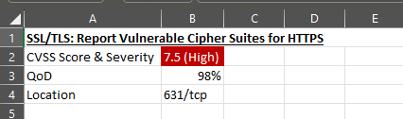

Figure 5: Vulnerability 1 – Excel Sheet

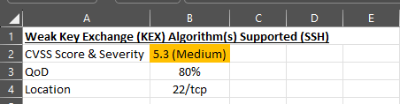

Figure 6: Vulnerability 2 – Excel Sheet

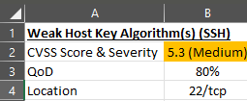

Figure 7: Vulnerability 3 – Excel Sheet

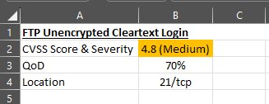

Figure 8: Vulnerability 4 – Excel Sheet

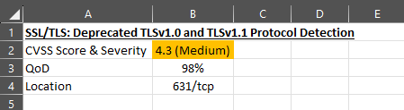

Figure 9: Vulnerability 5 – Excel Sheet

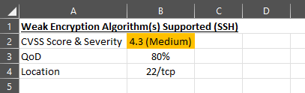

Figure 10: Vulnerability 6 – Excel Sheet

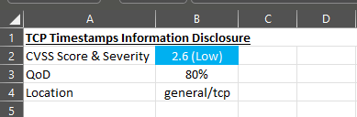

Figure 11: Vulnerability 7 – Excel Sheet

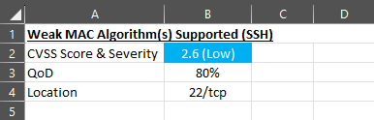

Figure 12: Vulnerability 8 – Excel Sheet

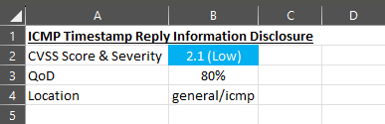

Figure 13: Vulnerability 9 – Excel Sheet

Metasploitable3 Machine Attack Simulation
In this segment of the report, I will discuss on how I simulated attack on the Metasploitable3 machine (Target IP Address: 192.168.1.38) using Kali Linux tools (Metasploit Framework and Nmap). I will discuss the two methods I have used to attack Metasploitable3 machine. I will effectively use screenshots as evidence.
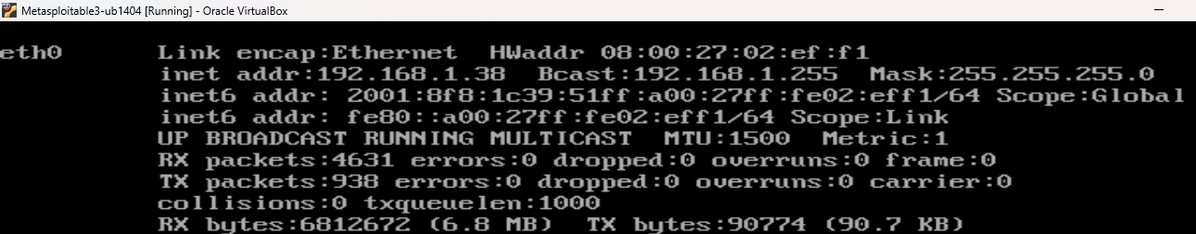

Figure 14: Record the IP Address of the target Metasploitable3 Machine using ‘ifconfig’

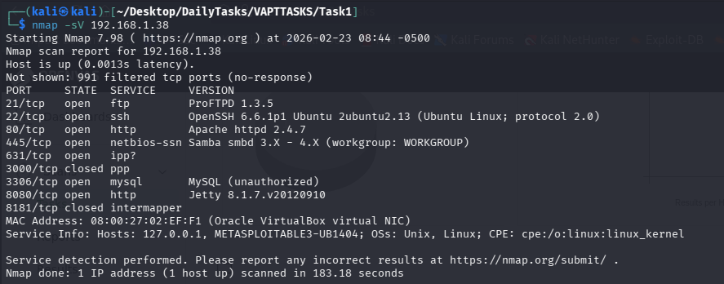

I am going to attack ftp service

Figure 15: Using nmap -sV to scan for open ports and services

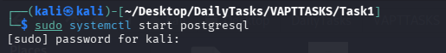

Figure 16: Step 1 – start postgresql

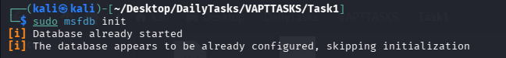

Figure 17: Step 2 – Check if the msf database started

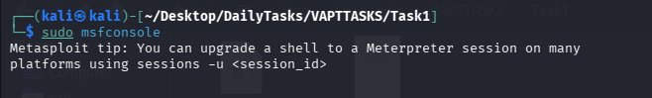

Figure 18: Step 3 – Enter the msfconsole

Figure 19: Step 4 – Check database status

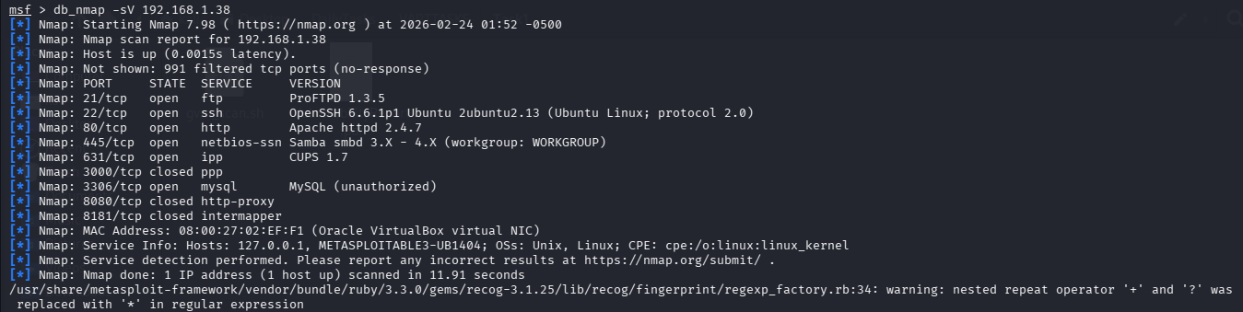

Figure 20: Step 5 – Check for open ports and services once again for verification

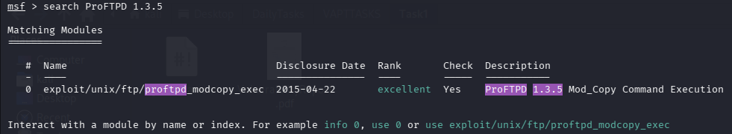

Figure 21: Step 6 – Search the version name for ftp service, to attack through the exploit

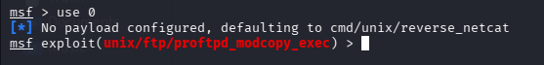

Figure 22: Step 7 – Use the exploit

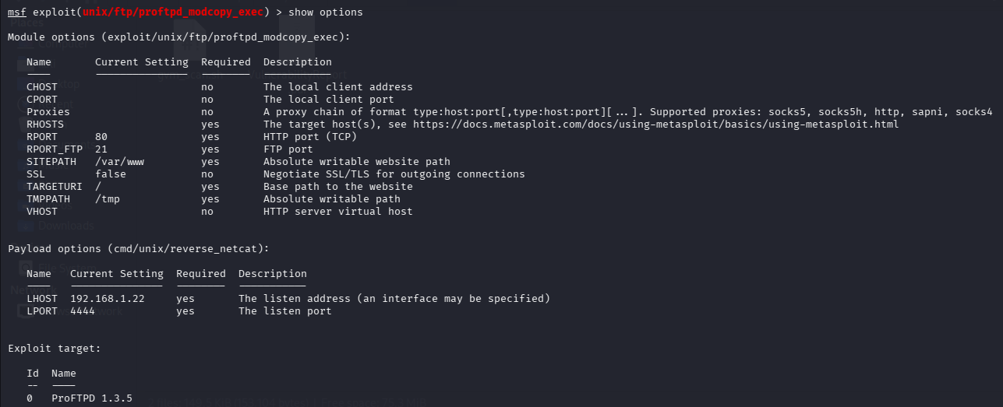

Figure 23: Step 8 – Check the options to fill

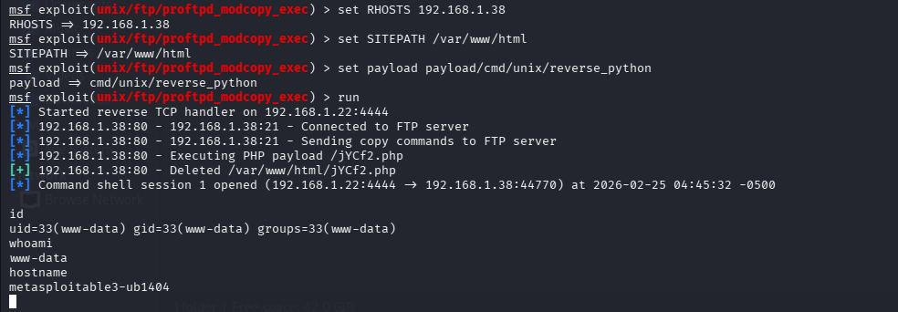

Figure 24: Step 9 – Fill the options and run the exploit

As shown above, I have successfully attacked the Metasploitable3 machine and gained access to its shell.

Another method I used to gain access to the shell is effectively shown below through the screenshots.

Once again enter the msfconsole as shown previously and start from there.

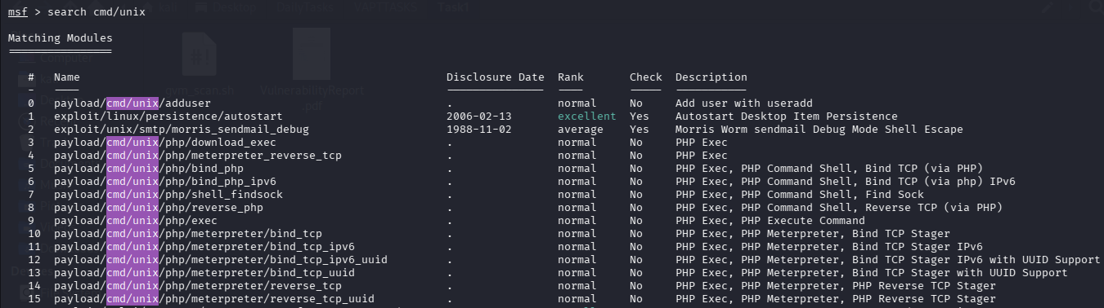

Figure 25: Step 1 – Search the payload to use

In this case, I will be using reverse_bash payload to gain access to Metapsloitable3 shell.

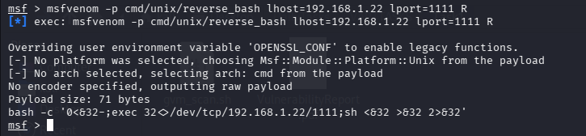

Copy this

Figure 25: Step 2 – Use the payload using msfvenom and set the options accordingly

Once I pressed enter, I have gotten the bash -c line. This is a very important line as when it is copied and pasted in the terminal of Metasploitable3 machine, I can gain access to Metasploitable3 shell through Kali Linux. This will be further shown through screenshots below.
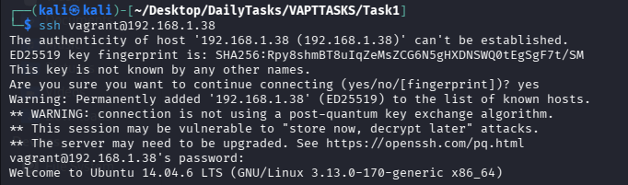

Figure 26: Step 3 – ssh to Metasploitable3 machine to access Metasploitable3 machine

Figure 27: Step 4 – Paste the copied bash -c line

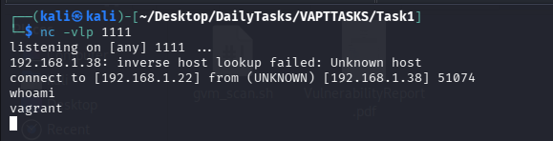

Figure 28: Step 5 – In the second session tab listen on the port 1111 and gain access to Metasploitable3 shell through Kali Linux machine.

Make sure, both the bash -c line and the command to listen on port runs simultaneously in their respective session tabs.

As shown above through the screenshots, I have once again gained access to Metasploitable3 shell, but through second method.

OWASP Juice Shop Attack Simulation
In this segment of the report, I will discuss on how I practiced in OWASP Juice Shop to attack it and exploits its web vulnerabilities like SQL Injection and Cross Site Scripting.

The below are the screenshots used as evidence to show the SQL Injection and Cross Site Scripting attacks I performed on this vulnerable website.

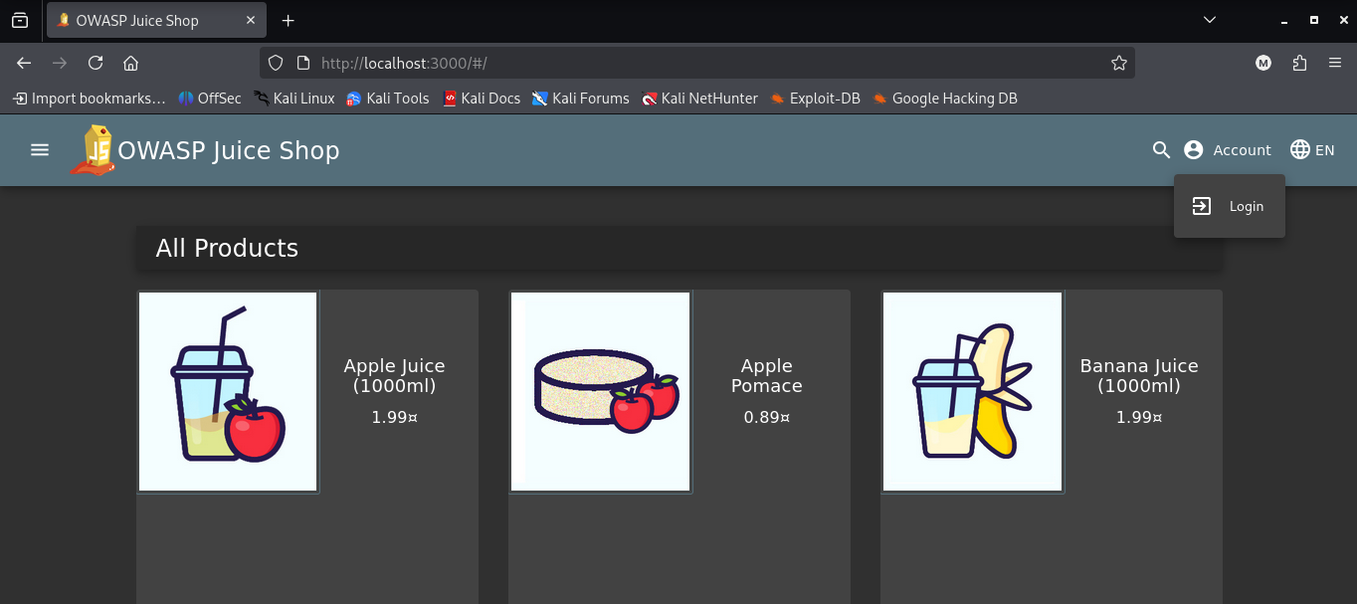

Figure 28: OWASP Juice Shop Homepage

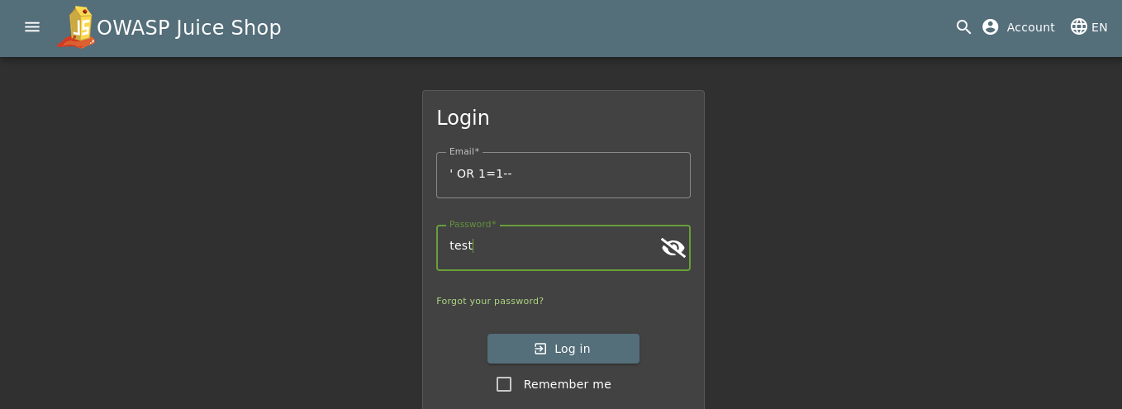

Figure 29: OWASP Juice Shop Login Page – Applying SQL Injection Attack in the field

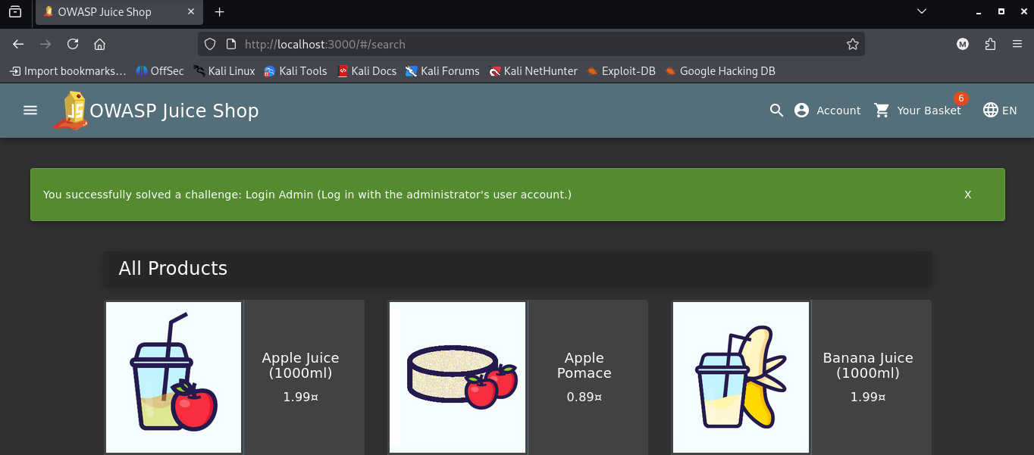

Figure 29: Once pressed ‘enter’, got admin access right away

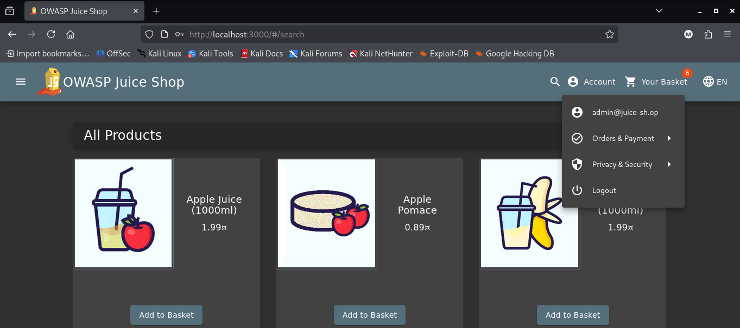

Figure 30: admin access

Figure 30: Performing XSS Attack by writing the line <img src=x onerror=alert(1)>

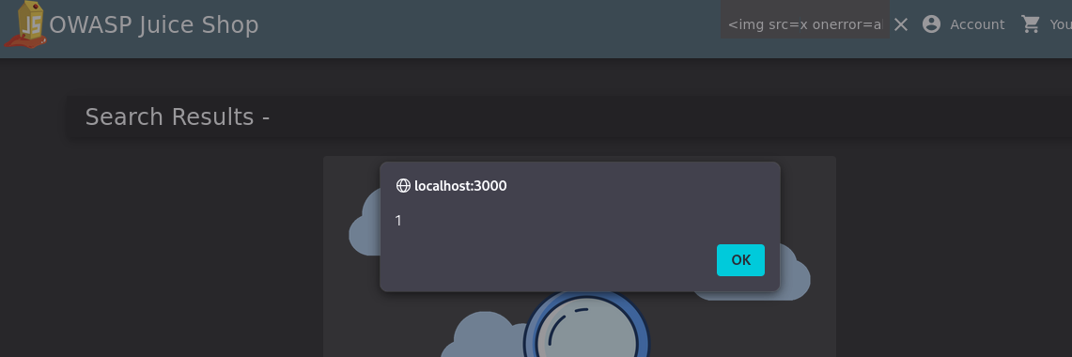

Figure 31: Pop up message appears. This shows XSS attack is successful.

OWASP Top 10 Vulnerabilities
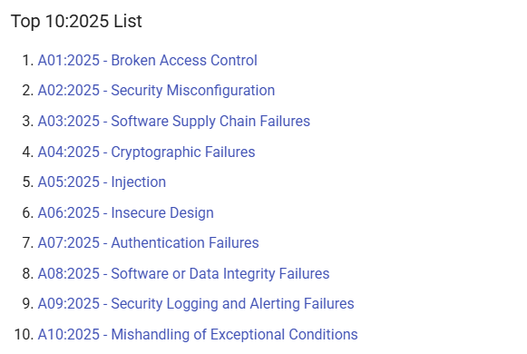

As shown in the screenshot above, Broken Access Control is number one in the list. However, Injection is number five on the list and I have discussed the SQL Injection vulnerability that OWASP Juice Shop has. Additionally, Insecure Design is number six on the list and it is another vulnerability that OWASP Juice Shop.

Lessons Learnt & Conclusion
By the successful completion of this first VAPT task, I got to learn a numerous amount of things from how to systematically conduct a comprehensive security assessment by combining theoretical knowledge with practical implementation to developing a clear understanding of how to use OpenVAS to identify vulnerabilities, interpret CVSS scores, and translate technical findings into structured risk analysis tables such as likelihood, impact, risk score calculations and risk matrix models for effective risk prioritization and remediation planning.

By successfully exploiting the Metasploitable machine using Kali Linux tools like Metasploit Framework and Nmap, I gained hands-on experience in reconnaissance, exploit selection, payload generation, and session handling, which strengthened my understanding of how attackers think and operate.

Additionally, by practicing SQL Injection and Cross-Site Scripting attacks on OWASP Juice Shop, I was able to connect real-world web vulnerabilities to concepts from the OWASP Top 10, reinforcing the importance of secure coding and proactive defense mechanisms. Overall, I learned the critical importance of structured risk assessment, proper documentation, vulnerability mitigation strategies, and ethical hacking practices in improving an organization’s overall security posture.

References
https://owasp.org/Top10/2025/

https://ualberta.scholaris.ca/server/api/core/bitstreams/b738bae1-0153-4f89-9d24-62224b0233cf/content

https://systemweakness.com/proftpd-exploitation-bb4a0cd19867

